lm(formula = Opioid.OD.deaths..2016. ~ Prescription.Rate.2016, 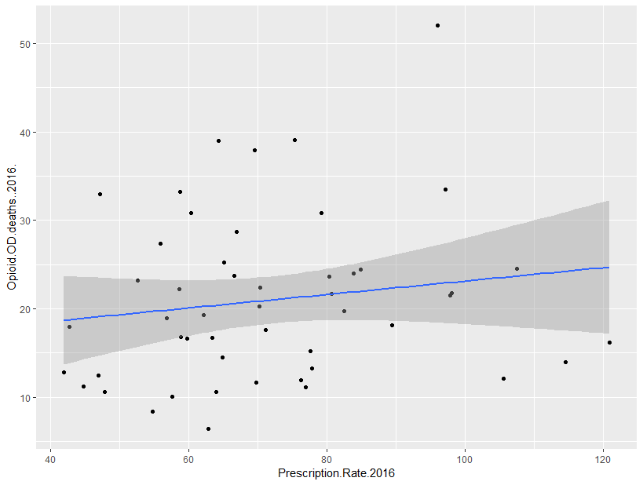

data = PrescriptionOverdose)

Residuals:

Min 1Q Median 3Q Max

-13.897 -7.444 -1.065 3.537 29.181

Coefficients:

Estimate Std. Error t value Pr(>|t|)

(Intercept) 15.52538 5.26705 2.948 0.00493 **

Prescription.Rate.2016 0.07598 0.07122 1.067 0.29140

---

Signif. codes: 0 ‘***’ 0.001 ‘**’ 0.01 ‘*’ 0.05 ‘.’ 0.1 ‘ ’ 1

Residual standard error: 9.359 on 48 degrees of freedom

**Multiple R-squared: 0.02316,** Adjusted R-squared: 0.00281

F-statistic: 1.138 on 1 and 48 DF, p-value: 0.2914